Phoenix Blog

Author: Ce Guo (Phoenix)
Update time: February 28, 2021

Phoenix Blog 1
1. Requirements and functionality design 2
1.1 Project requirements 2
1.2 Functionality design 4
2. Technology design 9
2.1 Architecture design 9
2.2 Development dependence 9
3. Database design 11
3.1 DataTable design 11
4. Interfaces design 14
4.1 Server-side interfaces design 14
4.2 Front-side interfaces design 16
5. Security, quality and usability 18
5.1 Security 18

Requirements and functionality design

Project requirements

Background requirements
Develop and deploy a personal web blog, which showcases your competences and expertise. At least one of the posts should be a reflective post on security, quality and usability within software projects.

Your web blog should allow your visitors to browse through the posts (articles) you have published, get information about your competences and expertise, leave comments on your posts, and contact you using email and social media.

Interface requirements
- header with navigation bar to enable the visitors to access all pages;
- section that displays the main content, e.g., the most important or latest blog posts;
- footer containing relevant links to additional information, e.g., contact details, privacy policy, disclaimer, etc.;
- you can also include a side bar to display any information you think is relevant and makes your website more attractive and usable.

Functionality requirements
- Home page should allow visitors to:
- view most important or recent blog posts (up to you to decide which posts you want to display) in the main content section of the page;
- click on a post (either the post’s title or image) so that the visitor views detailed information about the selected post;
- access login or registration pages (see explanation of content and functionality of these pages later);
- see personalized greeting in the top navigation bar if they are logged in, e.g., a logged in customer will be greeted by their first name (e.g., ’Hello, Jane!’). The visitor, who is not registered or logged it will see ’Hello, Guest!’ message.
- The individual blog post page should be used to display detailed information about a particular post, and allow the visitors to post comments. At least one of these posts should be a reflective post on security, quality and usability within software projects.
- ’All posts’ page should display all posts that you have ever created, and it should:
- Allow the visitors to access any post they wish to view.
- Be able to sort the posts by ascending or descending date.
- Registration page which should:
- Ask the visitors, who wish to register, to provide their first and last name, email address (which will they use to log in) and password.
- Perform a simple check that the visitor input their email address in the expected format, e.g., my_email@some_domain.com. (Note: this should be a simple check for the email address format - there is no need to check if this email address actually exists.)
– On successful registration the website should display a message to inform the user and redirect to home page.
– If registration is unsuccessful, the user should be informed, and will not be redirected to any other page.
- Inform the visitor if the registration is successful; or display a meaningful error message if there is a problem with the registration.
- Log in page which should:
- Enable a registered visitor to log in, and if successful, the visitor is redirected to the home page.
- Display an error message if there is a problem with a visitor’s login. NB: make sure that error messages do not jeopardize your website’s security.
- Allow a logged-in user to log out.
You might also want to develop more advanced functionality to earn additional marks:
- Search engine to allow the visitors to locate information on your website, e.g., to perform a search based on the posts’ titles or content;
- Ability for the user to rate each post, e.g., using ’like’ or ’star’ options. The ratings for each post should then be updated and displayed.
- Ability for the users to tag certain posts, after which a list of the tagged items is stored in the user’s account, and the user is able to access the list as well as delete certain tagged items from that list.

Functionality design
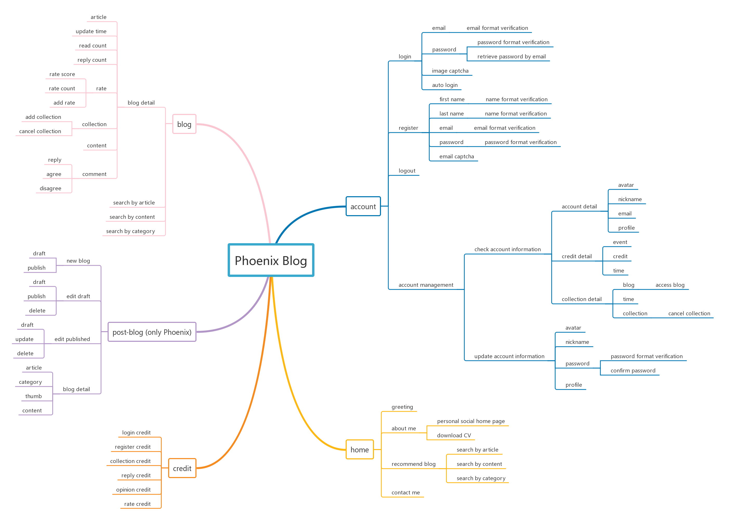

Functionality account
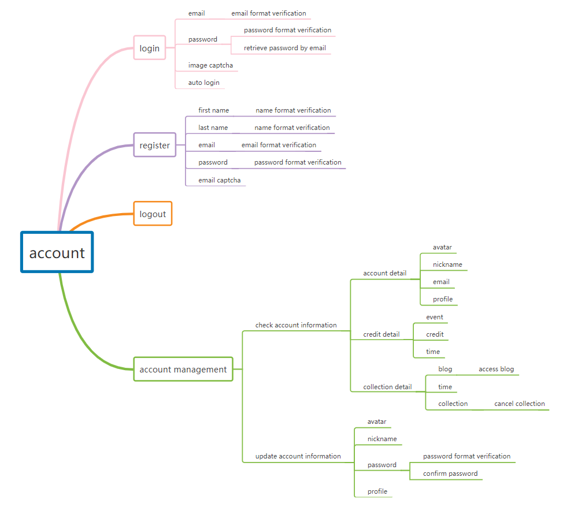

Functionality blog
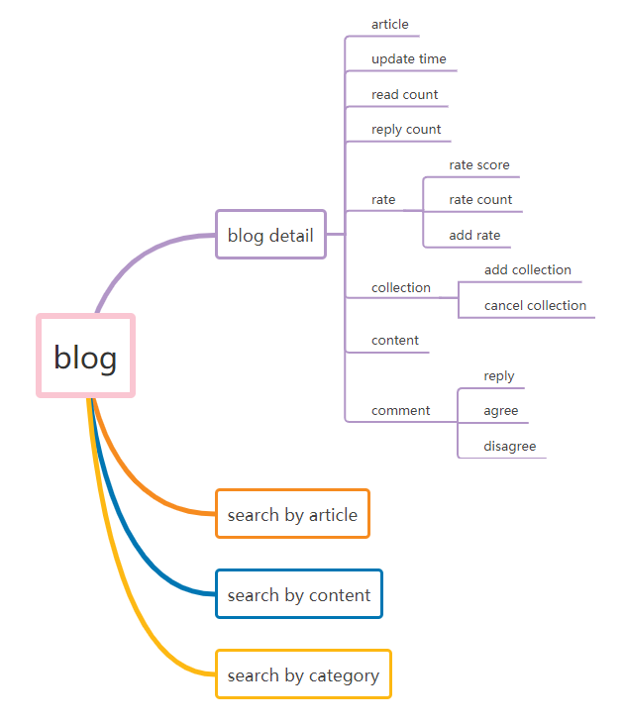

Functionality credit
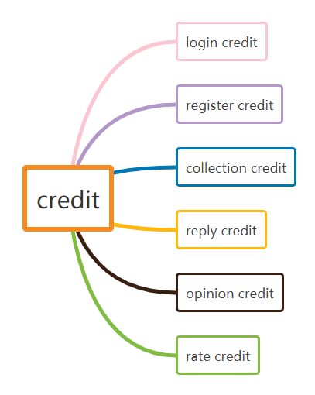

Functionality home
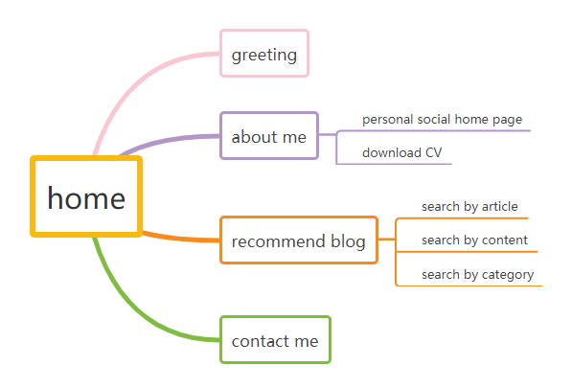

Functionality post-blog
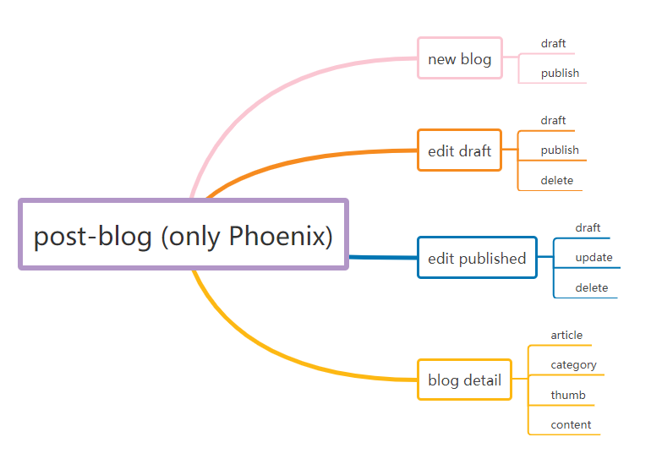

Technology design

Architecture design
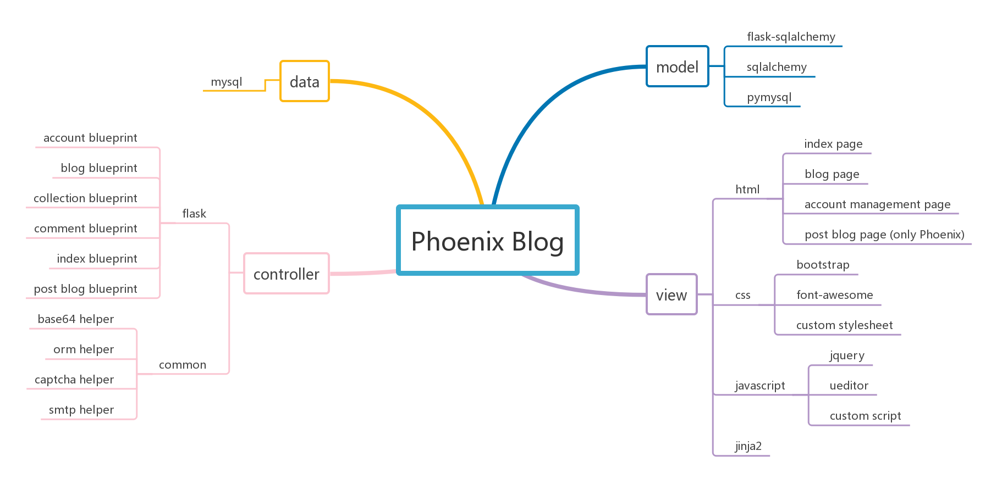

Development dependence

Server-side
- PyMySQL
Supports python operations on the database
- SQLAlchemy
Support python ORM of database operations
- Jinja2
Template engine supporting Flask rendering browser-side
- Flask
Server-side framework
- pillow
Support python image operation

Front-side
- JQuery
Support Ajax request and DOM element operations
- Bootstrap
Support responsive design
- ueditor
Support rich text editor
- font-awesome
Support icon and font resources

Data-side
- MySQL
Database

IDE
- PyCharm Professional
Integrated development environment

Debugging tool
- Postman
Debugging tool of server-side
- Chrome DevTools
Debugging tool of front-side

Database design

DataTable design

account
CREATE TABLE `account` (
`id` int (10) NOT NULL AUTO_INCREMENT,
`email` varchar (50) CHARACTER SET utf8 COLLATE utf8_general_ci NULL DEFAULT NULL,
`password` varchar (255) CHARACTER SET utf8 COLLATE utf8_general_ci NULL DEFAULT NULL,
`nickname` varchar (50) CHARACTER SET utf8 COLLATE utf8_general_ci NULL DEFAULT NULL,
`avatar` varchar (50) CHARACTER SET utf8 COLLATE utf8_general_ci NULL DEFAULT NULL,
`profile` varchar (255) CHARACTER SET utf8 COLLATE utf8_general_ci NULL DEFAULT NULL,
`credit` int (10) NULL DEFAULT NULL,
`createtime` datetime (0) NULL DEFAULT NULL,
`updatetime` datetime (0) NULL DEFAULT NULL,
PRIMARY KEY (`id`) USING BTREE
)

blog
CREATE TABLE `blog` (
`id` int(10) NOT NULL AUTO_INCREMENT,
`article` varchar (255) CHARACTER SET utf8 COLLATE utf8_general_ci NULL DEFAULT NULL,
`type` varchar (255) CHARACTER SET utf8 COLLATE utf8_general_ci NULL DEFAULT NULL,
`content` mediumtext CHARACTER SET utf8 COLLATE utf8_general_ci NULL,
`thumb` varchar (255) CHARACTER SET utf8 COLLATE utf8_general_ci NULL DEFAULT NULL,
`rate` tinyint(3) NULL DEFAULT NULL,
`ratecount` int (10) NULL DEFAULT NULL,
`readcount` int (10) NULL DEFAULT NULL,
`replycount` int (10) NULL DEFAULT NULL,
`draft` tinyint(1) NULL DEFAULT NULL,
`createtime` datetime (0) NULL DEFAULT NULL,
`updatetime` datetime (0) NULL DEFAULT NULL,
PRIMARY KEY (`id`) USING BTREE
)

collection
CREATE TABLE `collection` (
`id` int (10) NOT NULL AUTO_INCREMENT,
`email` varchar (50) CHARACTER SET utf8 COLLATE utf8_general_ci NULL DEFAULT NULL,
`articleid` int (10) NULL DEFAULT NULL,
`cancel` tinyint (1) NULL DEFAULT NULL,
`createtime` datetime (0) NULL DEFAULT NULL,
`updatetime` datetime (0) NULL DEFAULT NULL,
PRIMARY KEY (`id`) USING BTREE
)

comment
CREATE TABLE `comment` (
`id` int (10) NOT NULL AUTO_INCREMENT,
`email` varchar (50) CHARACTER SET utf8 COLLATE utf8_general_ci NULL DEFAULT NULL,
`articleid` int (10) NULL DEFAULT NULL,
`content` text CHARACTER SET utf8 COLLATE utf8_general_ci NULL,
`replyid` int (10) NULL DEFAULT NULL,
`agreecount` int (10) NULL DEFAULT NULL,
`disagreecount` int (10) NULL DEFAULT NULL,
`createtime` datetime (0) NULL DEFAULT NULL,
`updatetime` datetime (0) NULL DEFAULT NULL,
PRIMARY KEY (`id`) USING BTREE
)

credit
CREATE TABLE `credit` (
`id` int (10) NOT NULL AUTO_INCREMENT,
`email` varchar (50) CHARACTER SET utf8 COLLATE utf8_general_ci NULL DEFAULT NULL,
`type` varchar (50) CHARACTER SET utf8 COLLATE utf8_general_ci NULL DEFAULT NULL,
`event` varchar (255) CHARACTER SET utf8 COLLATE utf8_general_ci NULL DEFAULT NULL,
`target` int (10) NULL DEFAULT NULL,
`credit` int (10) NULL DEFAULT NULL,
`createtime` datetime (0) NULL DEFAULT NULL,
`updatetime` datetime (0) NULL DEFAULT NULL,
PRIMARY KEY (`id`) USING BTREE
)

Interfaces design

Server-side interfaces design

account controller
- @account_blueprint.route('/login', methods=['POST'])
Response for login
- @account_blueprint.route('/register', methods=['POST'])
Response for register
- @account_blueprint.route('/verification/image')
Response for login image captcha
- @account_blueprint.route('/verification/email', methods=['POST'])
Response for register email captcha
- @account_blueprint.route('/forget', methods=['POST'])
Response for login password forget
- @account_blueprint.route('/logout')
Response for logout
- @account_blueprint.route('/account')
Response for account page
- @account_blueprint.route('/account/profile', methods=['POST'])
Response for update account information

blog controller
- @blog_blueprint.route('/blog')
Response for first blog page
- @blog_blueprint.route('/blog/<int:current_page>')
Response for specific blog page
- @blog_blueprint.route('/blog-search-article/<int:current_page>-<keyword>')
Response for use specific page and keyword to search blog by article
- @blog_blueprint.route('/blog-search-content/<int:current_page>-<keyword>')
Response for use specific page and keyword to search blog by content
- @blog_blueprint.route('/blog-type/<int:current_page>-<type>')
Response for use specific page and category to search blog
- @blog_blueprint.route('/blog-article/<int:id>')
Response for blog detail
- @blog_blueprint.route('/rate', methods=['POST'])
Response for rate blog

collection controller
- @collection_blueprint.route('/collection', methods=['POST'])
Response for add collection
- @collection_blueprint.route('/collection/<int:article_id>', methods=['DELETE'])
Response for delete collection

comment controller
- @comment_blueprint.route('/comment', methods=['POST'])
Response for add comment
- @comment_blueprint.route('/reply', methods=['POST'])
Response for add reply
- @comment_blueprint.route('/opinion', methods=['POST'])
Response for add opinion

index controller
- @index_blueprint.route('/')
Response for home page
- @index_blueprint.route('/contact', methods=['POST'])
Response for contact me

post blog controller
- @post_blog_blueprint.route('/post-blog')
Response for post blog page
- @post_blog_blueprint.route('/post-blog/blog', methods=['POST'])
Response for post blog
- @post_blog_blueprint.route('/post-blog/load', methods=['POST'])
Response for load blog
- @post_blog_blueprint.route('/post-blog/blog/<int:id>', methods=['DELETE'])
Response for delete blog

Front-side interfaces design

Base.js
- loginOrRegister()
Request for login or register
- sendVerificationEmail ()
Request for email captcha
- sendForgetPasswordEmail ()
Request for forget password
- sendVerificationEmail ()
Request for image captcha

account.js
- updateProfile ()
Request for update account information
- cancelCollection(articleId)
Request for cancel collection

blog_article.js
- cancelCollection(articleId)
Request for cancel collection
- addCollection(articleId)
Request for add collection
- addComment(articleId)
Request for add comment
- addReply(articleId, commentId)
Request for add reply
- updateOpinion(commentId, type)
Request for update opinion
- addRate(articleId)
Request for add rate

blog_side.js
- searchBlog()
Request for search blog by article or content
- sortArticle()
Request for sort blog
- typeBlog(e)
Request for search blog by category

index.js
- sendContactEmail()
Request for contact

post_blog.js
- loadBlog(id)
Request for load blog
- postBlog(status)
Request for post blog
- deleteBlog()
Request for delete blog

Security, quality and usability

Security
Software security is to keep the system controlled by the software in a safe state that does not endanger human life, property and the ecological environment.

Measures
- Ensure the safety of the weakest link
- Defense in depth to avoid single point of failure
- Fail safe: enter a safe state to prevent unauthorized access to information
- Minimization criteria: minimize scope, minimize permissions
- Reduce risk through redundancy and diversity
- Verify all inputs

Solutions in Phoenix Blog
- The account password for a user must be strong, as well as encrypted in the database. The measure is to set minimum password requirements and encrypt the password with the MD5 function before being stored in the database.
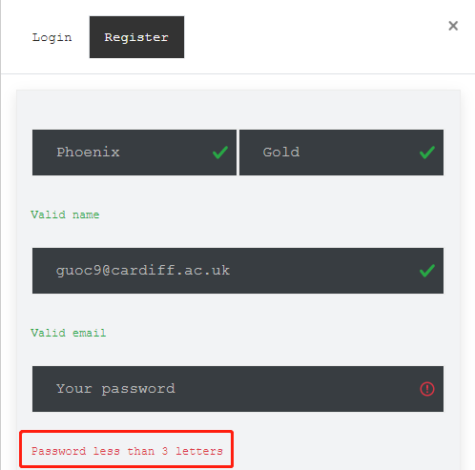
Code block:
password = hashlib.md5(password.encode()).hexdigest()
- The system must have the function of recording server-side errors to ensure errors can be observed and subsequently solved by the developers. The measure is to maintain a complete error log file at the server-side.
Code block:
if __name__ != '__main__':
gunicorn_logger = logging.getLogger('gunicorn.error')
application.logger.handlers = gunicorn_logger.handlers
application.logger.setLevel(gunicorn_logger.level)
- The system must limit the user's operation behavior because the front-end control right is completely open to the user, which may lead to a malicious operation. The measure is to limit the user's invalid behavior, such as illegal input and malicious request.
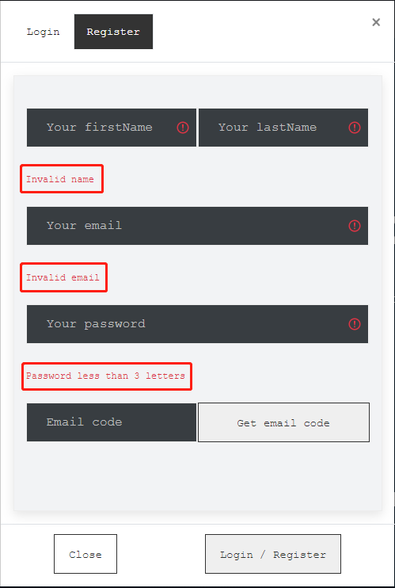
Code block:
$(document).ready(function () {
$("#loginEmail").bind('input propertychange', monitorInput);
$("#registerEmail").bind('input propertychange', monitorInput);
$("#loginPassword").bind('input propertychange', monitorInput);
$("#registerPassword").bind('input propertychange', monitorInput);
$("#registerFirstName").bind('input propertychange', monitorInput);
$("#registerLastName").bind('input propertychange', monitorInput);
})
- The system must have anti crawler function because an automatic script is likely to increase the server load and can potentially lead to interface crash. The measure is to use picture captcha and mailbox verification when there is human-computer interaction.
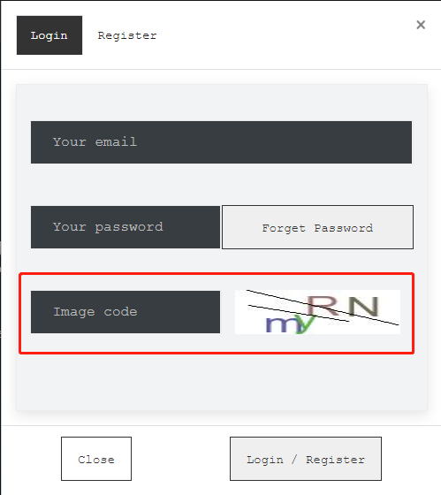
Code block:
@account_blueprint.route('/verification/image')
def verification_code():
try:
code, base64_str = ImageVerificationHelper().get_code()
session['image_code'] = code.lower()
return base64_str
except:
return 'Fail (Server) : Image code generate failed'
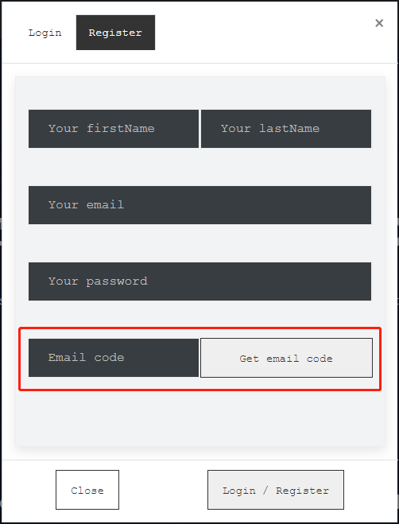
Code block:
@account_blueprint.route('/verification/email', methods=['POST'])
def verification_email():
try:
email = request.form.get('email').strip()
if not email:
return 'Fail (Server) : Invalid email'
account_model = AccountModel()
current_account = account_model.search_account_by_email(email)
if current_account:
return 'Fail (Server) : Account is existed'
code = EmailVerificationHelper().generate_code()
session['email_code'] = code
EmailVerificationHelper().send_email(email, code)
return 'Success (Server) : Verification email send successful'
except:
return 'Fail (Server) : Verification email send failed'
- The system must have cookie protection function to prevent cookie tampering; the measure is to encrypt and sign all sensitive cookies, and the session module in Flask can implement cookie encryption.
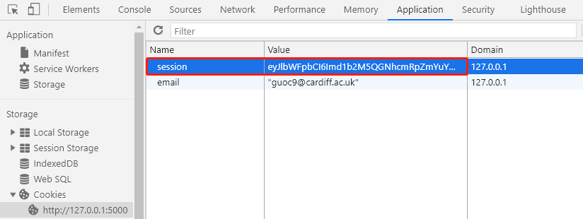
Code block:
session['login'] = 'true'
session['email'] = email
session['nickname'] = nickname

Quality
Software quality refers to the degree to which the software is consistent with the clearly stated function and performance requirements, the development standards clearly described in the document, and any professionally developed software products should have implicit features.

Guidelines
- Correctness: The degree to which the system meets the specifications and user goals, that is, the degree to which the expected function can be correctly completed under the predetermined environment;
- Robustness: The degree to which the system can respond appropriately in unexpected environments such as hardware failure, invalid input data, or operating errors;
- Efficiency: in order to complete the predetermined function, how much computing resources the system needs;
- Risk: the probability that the system is developed according to the predetermined cost and schedule, and the user is satisfied;
- Comprehensibility: how easy it is to understand and use the system;
- Maintainability: the amount of work required to diagnose and correct errors found at the operating site;
- Adaptability: the degree to which the software is easy to test;
- Portability: How much work is required to transfer a program from one hardware configuration and/or software system environment to another configuration and environment. There is a quantitative measurement method: divide the cost of transplantation by the cost of original program design and debugging;
- Reusability: The degree (or range) to which the program can be used again in other applications;
- Interoperability: How much work is required to combine this system with another system.

Solutions
- System should undergo regression testing after any change is made to the software, to ensure that no new issues have been created upon making changes; this will be measured by running a suite of tests against the main functions of the system after any change is made.
- All database information should be recoverable in the event of serious data loss, to make sure no assessment records are permanently lost; daily backups of the database will be made and tested to ensure this.
- System should be fault-tolerant, to ensure that the user experience will not be interrupted in the event of a server-side fault; this is measured by making sure a system is in place that redirects users to an available server when they attempt to connect to a faulty one.
- System should load quickly, to allow users to quickly access; first loading time should not exceed 3 seconds.
- System should respond to user's requests quickly, to allow users to quickly navigate and interact; response time should not exceed 2 seconds.
- The system should not require excess resource utilization, to ensure the operating speed of the system remains consistent; this will be measured by implementing all best practices, such as compressing pictures and script files.
- System can have a replicated database, so that the system does not have to go offline for maintenance to be performed. This will be measured by having the aforementioned database replication in place.
- All functions of the system can be fully modular to allow for maintenance of individual systems without compromising others.
- System can break down functionality into individual testable functions, and must contain automated test scripts, which perform tests on all main functions of the system, to ensure the system runs without errors.
- Can be modifiable to allow for the development of additional functionality in the future; measured by no features of the current system needing to be altered to allow the implementation of new features.

Usability
The usability of the software refers to the inclusion of the user’s concerns from the beginning of the design process, and stipulates that the user should be the most important factor in any design decision.

Solutions
- System should provide tips for every piece of information that needs explanation and contain help pages describing how to use the features of the system.
- Sufficient tutorials and documentation must be provided for users that contain instructions for all nontrivial functions of the system.
- Must provide an intuitive interface, in which all important pages that contain essential features can be accessed from the navigation bar in the header of each page, to ensure the site can be easily navigated by all users.
- If user enters invalid data, they are warned by the system, and prompted to enter valid data, to ensure that the user is not able to submit any invalid data; this will be measured by extensive testing, ensuring that all data entry is appropriately validated.

